

|  |  |  |  |  |  |  |  |  |
| --- | --- | --- | --- | --- | --- | --- | --- | --- |
|  | | | | | | | | |
|  | | Calibration of the Load cell | | | | |  | |
|  |  | | | | | | |  |
|  | | | |  |  | | | |
|  | | | | Arnav Jagtap |  | | | |
|  | | | | April 21, 2025—Project Course EE 299—Prof. Uttama Lahiri |  | | | |
|  | | |  | | |  | | |

# Introduction:

We performed calibration of the load cell to ensure accurate and reliable measurements of force and body orientation by verifying and adjusting sensor outputs with known reference values. We are using Hx711 to connect the load cell with Arduino Uno. Hx711 is Analog to digital converting module.

# Experimental Setup:

Equipment and Tools:

* Arduino UNO
* Hx711 module
* Arduino IDE
* 60710 Single Point Load Cell

# Methodology:

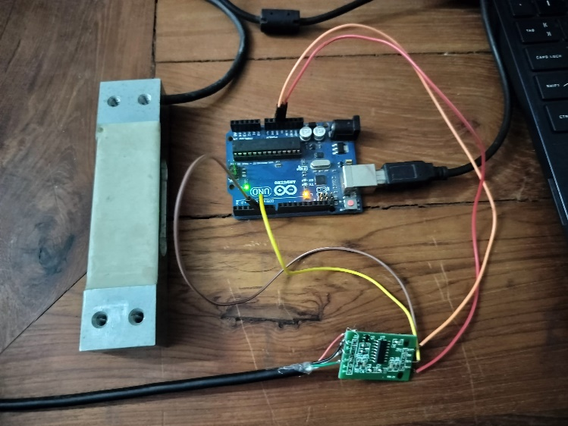

Figure 1

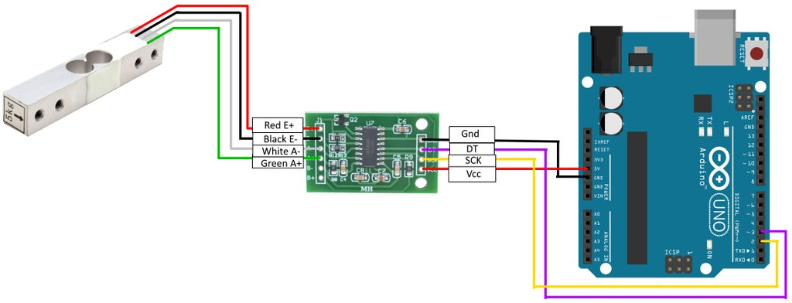

Figure 2 (image ref: <https://www.instructables.com/Arduino-Scale-With-5kg-Load-Cell-and-HX711-Amplifi/>)

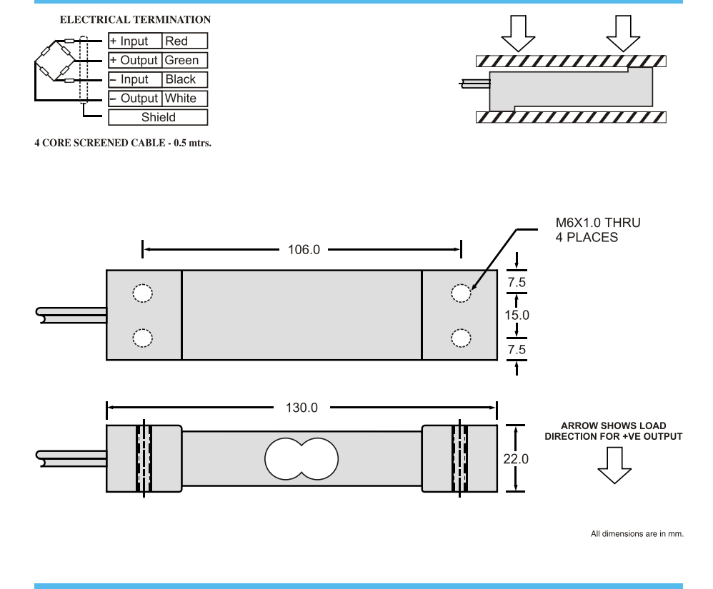

Figure 3 (image ref: <https://seegateloadcell.com/wp-content/uploads/2021/02/60710-loadcell-1.pdf>)

#include "HX711.h"

#define DOUT  4

#define CLK  5

HX711 scale;

void setup() {

  Serial.begin(9600);

  scale.begin(DOUT, CLK);

  Serial.println("Taring... Remove all weight");

  scale.tare();

  Serial.println("Tare done. Place a known weight now.");

}

void loop() {

  if (scale.is_ready()) {

    Serial.print("Reading: ");

    Serial.println(scale.get_units(10), 2); // 2 decimal places

  } else {

    Serial.println("HX711 not connected.");

  }

  delay(100);

}

1. We connected load cell and Arduino uno with the help of the hx711 module as shown in figure 1 and figure 2.
2. First we took the No load reading (Tare/Offset) =~ 12000
3. Known load applied = 2 Kg
4. Avg Raw Hx711 reading with 2 Kg = 224273
5. Raw difference due to 2 Kg = 224273 -12000 = 212273
6. Scale Factor (units per Kg) = 212273/2 = 106136.5
7. 1/Scale Factor = Gain
8. Weight = (Raw output – Offset) * Gain

# Results and Analysis:

Calibration procedure successfully evaluated the connection between actual weight and load cell output. With proper taring and calibration below Arduino code will provide the reliable and repeatable measurements for the weight measurement.

#include "HX711.h"

HX711 scale;

#define DT 3

#define SCK 2

void setup() {

  Serial.begin(9600);

  scale.begin(DT, SCK);

  scale.set_scale(106136.5);  // scale from calibration

  scale.tare();                // zero the scale

  Serial.println("Calibration complete. Place a weight.");

}

void loop() {

  Serial.print("Weight (kg): ");

  Serial.println(scale.get_units(), 2);

  delay(1000);

}